Pac-Poly-Hi-Hi-Pali-Battle Ground

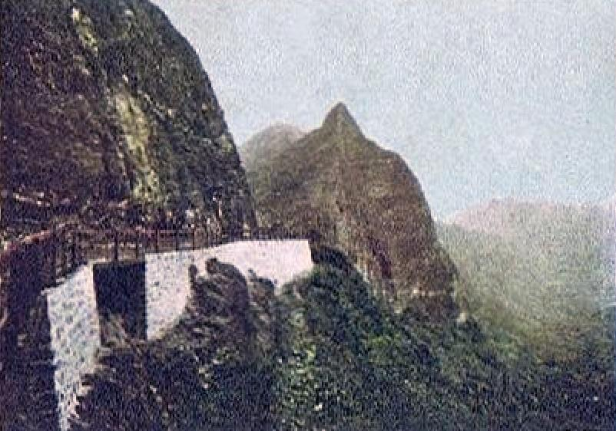

PALI - ANCIENT HAWAIIAN BATTLE GROUND

PRIVATE MAILING CARD

PUBLISHED BY THE ISLAND CURIO STORE - HONOLULU-1905

